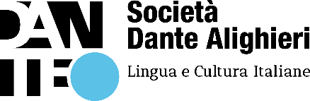
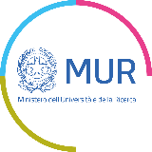

Free online Italian courses

for university students and workers with international or special protection

Second edition

Rules for participation

Società Dante Alighieri (SDA) and the Ministry of University and Research (MUR) are pleased to announce the launch of the second edition of free online Italian language courses aimed at university students, teachers and researchers with international or special protection.

These free online courses are open to:
- students enrolled in Italian universities/conservatory/academy of fine arts
- researchers at an Italian universities/conservatory/academy of fine arts or at a research centre recognized by the MUR and
- professors and visiting professors

SDA, founded in Rome in 1889, operates around the world in over 80 countries and with a network of 400 Committees. Its aims include spreading Italian language and culture.
As part of this mission, and in agreement with MUR, SDA offers free online courses on the Dante.global platform. The courses teach linguistic skills to improve academic careers and promote linguistic integration in Italy.

To access the courses, applicants must:
- be entitled to international or special protection
- be enrolled as a student or be employed at an Italian university/conservatory/academy of fine arts.

Application form
If you are interested in registering, please go to www.dante.global and complete the application form or write to progetti@dante.global.
You will need to fill in every field of the form and attach your residence permit or Italian identity card.

IMPORTANT: always use the same e-mail address for the application, registration on the platform and all related communications.

After submitting your application form, within a few days you will receive an email from SDA containing the following two links:
- link to analysis of needs and linguistic placement test in Italian (reading and writing); and
- link to arrange Zoom interview with one of our teachers (in order to meet you, confirm your identification and complete the linguistic placement in Italian).

IMPORTANT: applicants have until 31 March 2024 to complete registration, and the free online courses start from 6 May 2024.

By 31 March 2024, you must:
- complete the linguistic placement test in Italian (reading and writing);
- book the Zoom interview with one of our teachers.

Based on your needs and your skills in the Italian language, courses will be offered according to the CEFR levels A1, A2, B1, B2.

The start date of your course will be communicated to you via email, together with the methods of accessing the Dante.global platform and your identification code.

Please note that every course:
- includes 20 hours of lessons per week (10 hours in synchronous e-learning in the presence of the teacher and 10 hours in asynchronous self-learning) with tutoring and IT support
- includes an Italian language e-book
- ends in November 2024 with the PLIDA Italian language certification exam, recognized throughout the world. The certification exam is allowed only with at least 70% of attendance.

IMPORTANT: SDA provides free of charge the relevant free online courses, teaching materials and PLIDA certification.

SDA reserves the right to make changes to this regulation, in agreement with the MUR.

All documentation acquired will be treated according to the relevant current legislation and in compliance with the privacy policy of SDA. Upon completion of each applicant’s registration and identification, SDA will delete and not retain any identity documents received.

